**Project Documentation: Real-Time Medical Check System**

**BSE-05-0134/2022 Maina Leakey 0705223888**

**BSE-05-0165/2022 Wahome Maina 0794797796**

**Chapter 1: Introduction**

**1.0 Background**

**Global Context**

Healthcare systems worldwide face significant challenges, including increasing patient volumes, limited medical resources, and delays in diagnosis. Traditional diagnostic approaches rely on periodic physical check-ups and laboratory testing, often resulting in delayed detection of medical conditions. These delays can lead to disease progression and more complex treatment requirements, placing additional burdens on healthcare infrastructures. In response, digital health innovations have introduced real-time health monitoring solutions that enable early detection and intervention, improving patient outcomes and optimizing healthcare resources. 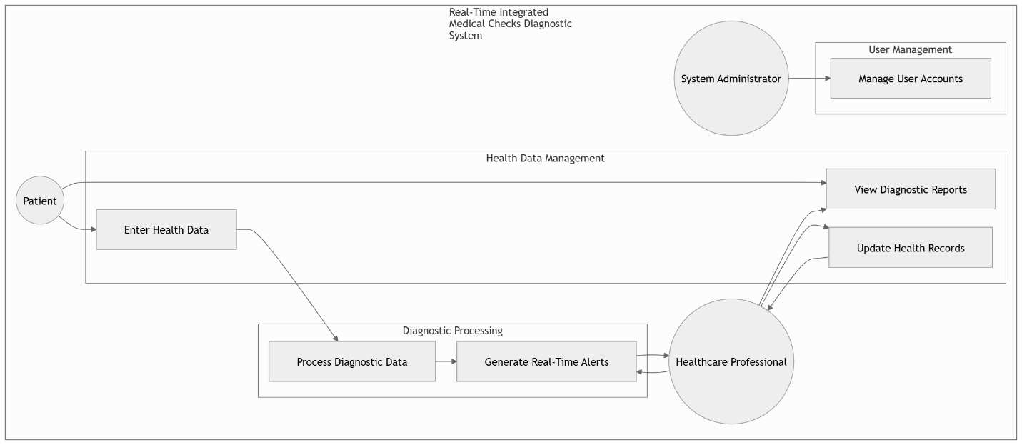The integration of artificial intelligence (AI) and Internet of Things (IoT) in medical diagnostics has significantly advanced global healthcare, facilitating remote patient monitoring and predictive analytics.

**Local Context**

In many regions with limited healthcare access, including remote and underserved areas, diagnostic delays are even more pronounced. Many patients only consult medical professionals sporadically due to logistical and financial constraints. In Kenya, for instance, the doctor-to-patient ratio remains far below the World Health Organization (WHO) recommendation, further complicating timely medical attention. The development and implementation of a Real-Time Medical Checks Diagnostic System (RTMCDS) could bridge this gap by providing continuous monitoring and early intervention, ultimately reducing the strain on healthcare facilities and improving patient care.

**1.1 Problem Statement**

The traditional medical diagnosis process relies heavily on scheduled check-ups and laboratory-based diagnostics, leading to delayed detection of potential health complications. Limited healthcare access, high patient-to-doctor ratios, and the lack of real-time monitoring contribute to worsening health conditions before intervention occurs. This project seeks to address these gaps by developing a Real-Time Medical Checks Diagnostic System (RTMCDS) that continuously monitors patient vitals, detects abnormalities, and provides immediate diagnostic insights.

**1.2 Objectives**

**1.2.1 General Objective**

To develop a Real-Time Medical Checks Diagnostic System that enables continuous health monitoring, early detection of anomalies, and real-time diagnostics, improving patient care and medical efficiency.

**1.2.2 Specific Objectives**

* To design and implement a system capable of continuously monitoring vital health parameters such as heart rate, blood pressure, and oxygen saturation.
* To integrate AI-driven analytics for early detection and prediction of potential health risks.
* To develop a user-friendly interface for healthcare professionals and patients to access real-time diagnostic data.
* To evaluate the system’s effectiveness in improving early diagnosis and reducing patient-doctor visit gaps.
* To ensure data security and privacy compliance within the system.

**1.3 Research Questions**

* How can real-time health monitoring improve early diagnosis and intervention?
* What are the key parameters required for an effective real-time medical diagnostic system?
* How can AI be leveraged to enhance diagnostic accuracy and predict potential health issues?
* What challenges might arise in implementing RTMCDS in resource-limited settings?
* How can user experience be optimized to ensure widespread adoption by both healthcare professionals and patients?

**1.4 Justification**

The RTMCDS aims to revolutionize the healthcare landscape by introducing proactive and continuous monitoring rather than reactive treatment approaches. With the increasing global burden of chronic diseases such as hypertension and diabetes, early detection through real-time monitoring can lead to better disease management and reduced healthcare costs. Moreover, this system aligns with global efforts to integrate AI and IoT into healthcare, making medical services more accessible, efficient, and predictive.

**1.5 Significance**

This project is significant to multiple stakeholders, including:

* **Patients:** Enables early detection and timely intervention, reducing health complications and improving quality of life.
* **Healthcare Providers:** Assists in diagnosing and monitoring patients more efficiently, reducing hospital congestion.
* **Medical Researchers:** Provides valuable real-time health data for further studies on disease prediction and management.
* **Healthcare Systems:** Helps optimize resource utilization and reduces unnecessary hospital visits, lowering operational costs.

**1.6 Scope and Limitations**

The scope of this project includes the development of a real-time medical diagnostic system that integrates continuous health monitoring, AI-driven analysis, and a user interface for accessing diagnostic insights. The system will be designed primarily for non-invasive health metrics, such as heart rate, blood pressure, and oxygen saturation.

**Limitations:**

* **Data Accuracy:** AI predictions require significant training and validation to ensure high accuracy.
* **Integration Challenges:** Compatibility with existing healthcare infrastructure may pose difficulties.
* **Privacy and Security:** Ensuring compliance with health data regulations and preventing unauthorized access to patient information.
* **User Adoption:** Encouraging both healthcare professionals and patients to trust and effectively use the system.

**Chapter 2: Literature Review**

**2.1 Overview of Real-Time Health Monitoring Systems**

Real-time health monitoring systems have evolved from basic periodic check-ups to sophisticated systems that continuously collect and analyze patient data. Early systems relied on scheduled measurements in clinical settings, but advancements in sensor technology and data analytics have enabled continuous monitoring in non-clinical environments.

Recent research shows that these systems can significantly reduce emergency situations by detecting anomalies before they escalate (Marr, 2020; WHO, 2021). In our context, RTMCDS leverages non-invasive sensors to monitor vital parameters such as heart rate, blood pressure, and oxygen saturation continuously, facilitating early intervention and personalized healthcare.

**2.2 Artificial Intelligence in Medical Diagnostics**

The integration of artificial intelligence in medical diagnostics has revolutionized how data is interpreted. Machine learning models—including neural networks, support vector machines, and decision trees—are used to identify subtle patterns in complex datasets that may be imperceptible to human observers. These AI algorithms improve diagnostic accuracy by learning from vast amounts of historical and real-time data (Patel et al., 2022).

Furthermore, deep learning techniques have been explored for image analysis in radiology and pathology, setting a precedent for their application in analyzing sensor data for continuous health monitoring. The challenge remains in ensuring these algorithms are trained on diverse datasets to avoid biases and ensure high reliability across various demographic groups.

**2.3 IoT-Based Health Monitoring Systems**

The Internet of Things (IoT) has been pivotal in advancing real-time health monitoring systems. IoT facilitates the interconnection of sensor devices, enabling seamless data transfer to centralized systems where analysis can be performed in real time. Protocols such as MQTT and CoAP ensure efficient data transmission even in bandwidth-limited environments.

These systems have been deployed in remote and rural settings, demonstrating their potential to overcome geographical barriers to healthcare (Vasilenko et al., 2023). However, challenges related to data interoperability, network security, and scalability remain critical focal points for ongoing research.

**2.4 Challenges in Implementing Real-Time Medical Diagnostics**

Despite advancements, real-time medical diagnostics face several challenges:

* **Data Reliability and Accuracy:** Sensor malfunctions, environmental interference, and calibration issues can compromise data integrity. Ensuring robust error detection and correction mechanisms is essential.
* **Infrastructure Requirements:** Reliable internet connectivity, sufficient computational power, and secure cloud storage are prerequisites that may be lacking in some regions.
* **Privacy and Security:** The sensitive nature of health data requires strict adherence to data protection regulations, such as HIPAA and GDPR, and the implementation of advanced encryption techniques.
* **User Acceptance:** Both healthcare professionals and patients must trust the system. Continuous education and intuitive system design are key to enhancing user adoption.

**2.5 Comparative Analysis of Current Systems**

Current state-of-the-art systems vary in their approach to real-time monitoring. Some systems focus on a narrow range of vitals, while others integrate a broader spectrum of health indicators. Comparative studies indicate that systems integrating AI-driven analytics offer superior predictive capabilities compared to traditional monitoring methods.

However, many existing systems still face integration issues with legacy healthcare infrastructures. The RTMCDS aims to build on these systems by providing a scalable, flexible solution that can be adapted to various healthcare settings and requirements.

**2.6 Summary of Key Findings and Research Gaps**

In summary, the literature indicates substantial benefits of real-time monitoring combined with AI for early diagnosis and healthcare efficiency. However, gaps remain in addressing data accuracy, system integration, and user trust. These research gaps form the basis for the development of the RTMCDS, which seeks to incorporate best practices from existing studies while addressing the limitations identified in the current literature.

**Chapter 3: Methodology**

**3.0 Introduction**

This chapter outlines the research approach, data collection methods, and system development methodology used to build the RTMCDS. It describes how the study was conducted, including ethical considerations.

**3.1 Research Design**

This study adopts a mixed-methods research design that combines both qualitative and quantitative approaches. The quantitative component will involve system performance testing, data accuracy assessments, and statistical analysis of diagnostic outcomes.

The qualitative component will include user experience evaluations through interviews and surveys with healthcare professionals and patients. This comprehensive approach ensures a robust evaluation of the system's efficacy and usability.

**3.2 System Development Methodology**

The development of the RTMCDS will follow the Agile methodology. This iterative approach facilitates continuous improvement through regular feedback loops. Key phases include:

* **Requirement Analysis:** Engaging stakeholders to define system specifications.
* **Design and Prototyping:** Creating wireframes, system architecture diagrams, and initial prototypes.
* **Development and Integration:** Incrementally building system components such as sensor integration modules, cloud storage, and the AI processing unit.
* **Testing and Validation:** Conducting unit tests, system integration tests, and user acceptance tests to ensure system reliability.
* **Deployment and Feedback:** Rolling out the system in controlled settings and gathering iterative feedback for further refinement.

**3.3 Data Collection Methods**

To ensure comprehensive system evaluation, multiple data collection methods are employed:

* **Quantitative Data:** This includes sensor data logs, system performance metrics, and diagnostic accuracy rates. Statistical analysis will be performed to assess the system’s effectiveness.
* **Qualitative Data:** Semi-structured interviews and surveys will be conducted with healthcare professionals and patients to gather insights on usability, system reliability, and overall user satisfaction.
* **Secondary Data:** A thorough review of existing literature and case studies related to real-time monitoring systems, AI in diagnostics, and IoT applications in healthcare.

**3.4 System Architecture**

The RTMCDS will be designed with a modular architecture comprising:

* **Sensor Module:** Utilizes non-invasive sensor technology to monitor vital signs such as heart rate, blood pressure, and oxygen saturation.
* **Cloud-Based Storage:** Secure, scalable storage solutions for real-time data collection and historical data archiving.
* **AI Processing Unit:** Employs machine learning algorithms for pattern recognition, anomaly detection, and predictive analysis.
* **User Interface:** A web and mobile dashboard that provides real-time insights and diagnostic recommendations to healthcare providers and patients.
* **Communication Layer:** Implements secure data transmission protocols to ensure the integrity and confidentiality of health data.

**3.5 Software Development Lifecycle and Tools**

The system will be developed using a suite of modern tools and frameworks:

* **Programming Languages:** Python for AI algorithm development and JavaScript, HTML. CSS for front-end development.
* **Frameworks:** PyTorch for machine learning, and React or Angular for the user interface.
* **Testing Tools:** Automated testing frameworks (e.g., Selenium for UI testing, PyTest for backend testing) will be employed to ensure system reliability and performance.
* **Version Control and Collaboration:** Git and collaborative platforms like GitHub or GitLab will be used to manage code and project documentation.

**3.6 Ethical Considerations**

The project adheres to strict ethical guidelines to protect patient privacy and ensure data security:

* **Data Protection:** All patient data will be encrypted using industry-standard protocols during transmission and storage.
* **Compliance:** The system will comply with relevant health data regulations, such as HIPAA and GDPR, ensuring that data is handled with the utmost care.
* **Informed Consent:** Participants in any user testing or pilot studies will be fully informed about the purpose of the study, data usage, and their rights, with written consent obtained before participation.
* **Risk Mitigation:** Strategies will be in place to address any potential data breaches or system failures promptly and transparently.

**3.7 Evaluation and Validation Strategy**

To ensure the RTMCDS meets its intended objectives, a comprehensive evaluation strategy will be implemented:

* **Performance Metrics:** System response time, data accuracy, and anomaly detection rates will be measured and analyzed.
* **User Feedback:** Iterative testing sessions will gather feedback from healthcare professionals and patients to refine the user interface and overall functionality.
* **Pilot Studies:** Controlled deployment in select healthcare settings will provide real-world data on system performance, guiding further enhancements.
* **Comparative Analysis:** Results from the RTMCDS will be benchmarked against traditional diagnostic methods to assess improvements in early diagnosis and patient outcomes.

**Chapter 4: System Analysis and Design**

**4.0 Introduction**

In this chapter, we present the complete analysis and design of the Real-Time Medical Checks Diagnostic System (RTMCDS). This chapter outlines the systems development methodology we employed, presents our feasibility study, details our requirements elicitation and analysis, and describes both the logical and physical design of the system.

We then provide a comprehensive system architecture and include several diagrams (such as context diagrams, partitioned DFDs, UML diagrams, ER diagrams, and interface mockups) to visually demonstrate our design approach.

**4.1 Systems Development Methodology**

We adopted the Agile methodology for our project. Agile allows for iterative design and development cycles, continuous user feedback, and the flexibility to adapt requirements as we progress.

Early prototyping and regular reviews with stakeholders (healthcare professionals, potential patients, and technical experts) have guided our design choices and ensured that our system meets the needs outlined in our objectives.

**4.2 Feasibility Study**

A feasibility study was conducted to determine whether the RTMCDS could be implemented within available technical, financial, and time constraints. Our study confirmed that:

* **Technical Feasibility:** The required technologies (web development frameworks, cloud-based storage, and machine learning libraries) are well-established and readily available.
* **Economic Feasibility:** The projected costs are within budget, and the system promises to reduce healthcare inefficiencies, yielding long-term savings.
* **Operational Feasibility:** Feedback from a small group of healthcare professionals and potential end-users indicates strong support and willingness to adopt the system.
* **Legal and Regulatory Feasibility:** Data protection and privacy regulations (e.g., HIPAA, GDPR) are addressed through robust security measures.

**4.3 Requirements Elicitation**

**4.3.1 Data Collection Tools and Process**

To gather accurate and relevant system requirements, we employed multiple data collection methods:

* **Interviews:** Conducted with 5 healthcare professionals to identify key diagnostic needs and usability concerns.
* **Questionnaires:** Distributed to 15 potential patients to gather insights on user interface preferences and expectations.
* **Observations:** Performed in selected healthcare settings to understand current diagnostic workflows.

These tools were refined and approved by our supervisor before administration. The collected data was analyzed using statistical tools (Excel) and represented through pie charts and bar graphs to identify trends and user requirements.

**4.3.2 Data and System Analysis**

The data collected helped us:

* Identify the essential inputs (e.g., user-entered health data, historical patient records) and outputs (real-time diagnostics, trend analyses, alerts).
* Determine that the system must support functionalities such as real-time data processing, user notifications, and detailed reporting.
* Deduce system performance requirements, including response times and data accuracy benchmarks.

**4.4 System Specification**

Based on our analysis, the RTMCDS will perform the following functions:

* **Input:** Users (healthcare professionals and patients) enter health data via web forms or upload historical records.
* **Processing:** The system utilizes AI-driven analytics (implemented in Python using PyTorch) to analyze the input data for anomalies and generate diagnostic insights.
* **Output:** The system produces real-time alerts, detailed diagnostic reports, and historical trend analyses displayed through an interactive web/mobile dashboard.

We have defined the system requirements in clear, non-ambiguous terms using models such as data flow diagrams, UML class and use-case diagrams, and an entity-relationship diagram (ERD).

**4.5 Design**

**4.5.1 Logical Design**

* **Rich Picture and Context Diagram:**  
  We have developed a rich picture that captures the overall environment and stakeholders of the system. A context diagram illustrates the system's boundaries and its interactions with external entities (e.g., healthcare providers, patients).
* **Wireframes:**  
  Initial wireframes for the user interface depict the main screens (login, data entry forms, dashboard, and reports) and navigation flow.

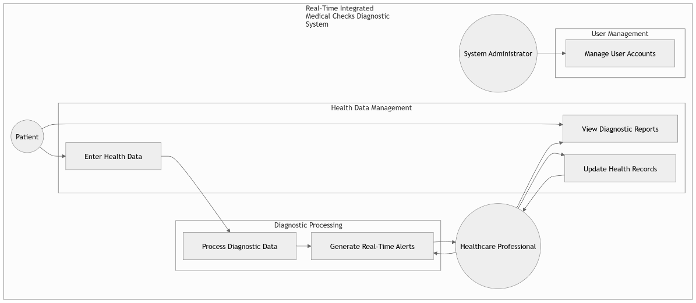

**4.5.2 Physical Design**

* **UML Diagrams:**
  + **Use Case Diagram:** Depicts the interactions between the system and its actors (healthcare professionals, patients, and system administrators).

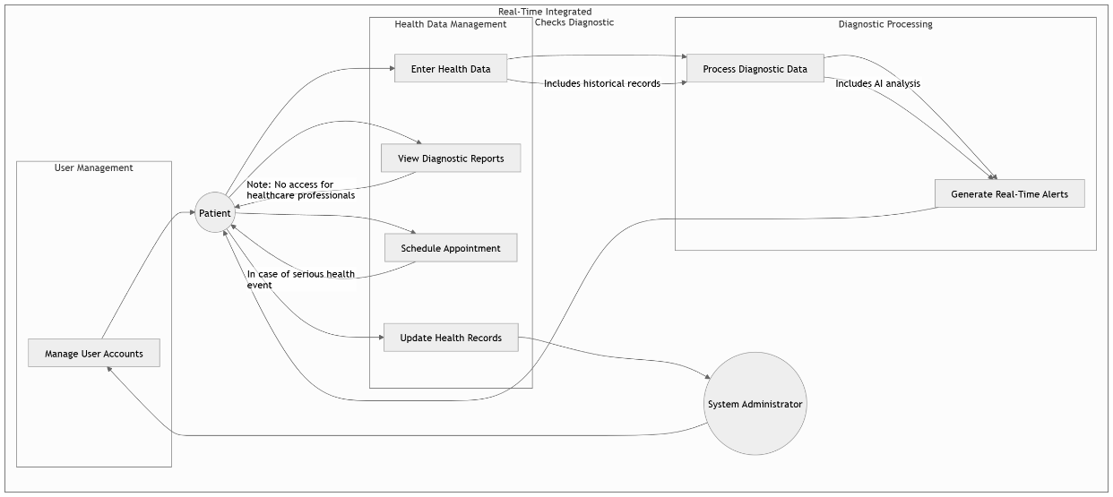

**Figure 4.2:** UML Use Case Diagram.

* + **Sequence Diagram:** Details the flow of data from user input through processing to output generation.
  + **Class Diagram:** Defines the key classes (e.g., User, HealthData, DiagnosticEngine, ReportGenerator) and their relationships.

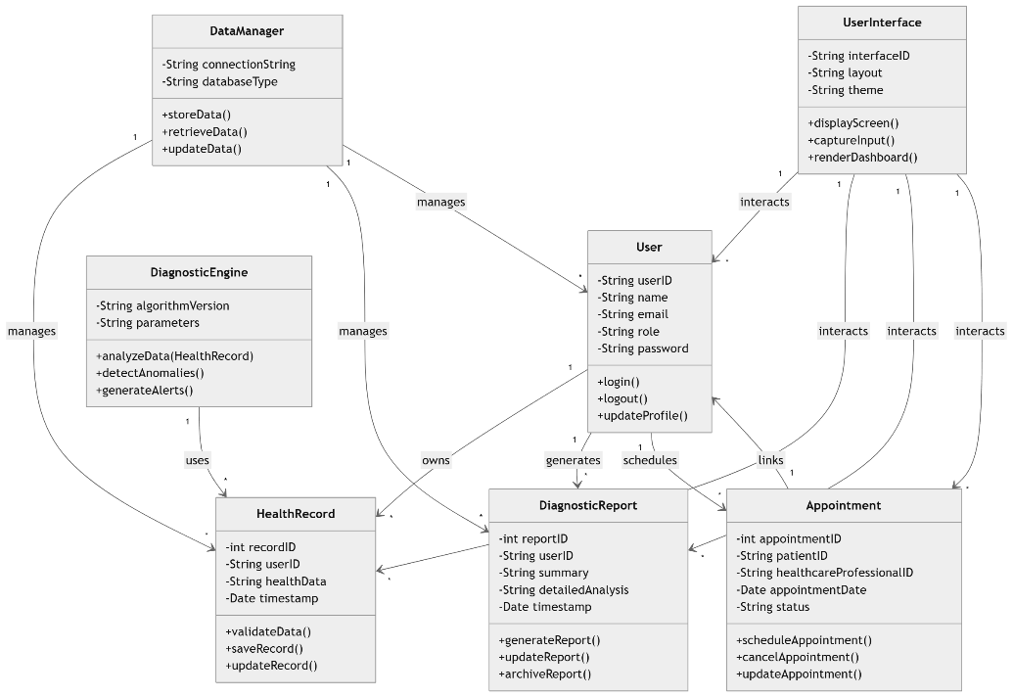

**Figure 4.3:** UML Use Class Diagram.

* **Data Flow Diagrams (DFDs):**  
  A partitioned DFD shows the flow of data from input to processing and output, ensuring that every requirement is mapped to a process within the system.

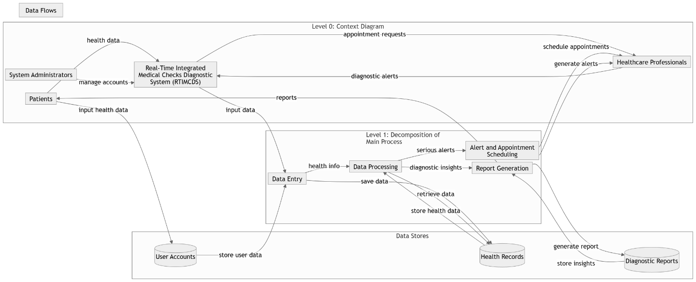**Figure 4.4:** Partitioned Data Flow Diagram.

* **Entity Relationship Diagram (ERD):**  
  Illustrates the major entities (User, HealthRecord, DiagnosticReport) and their attributes, ensuring a normalized database design.

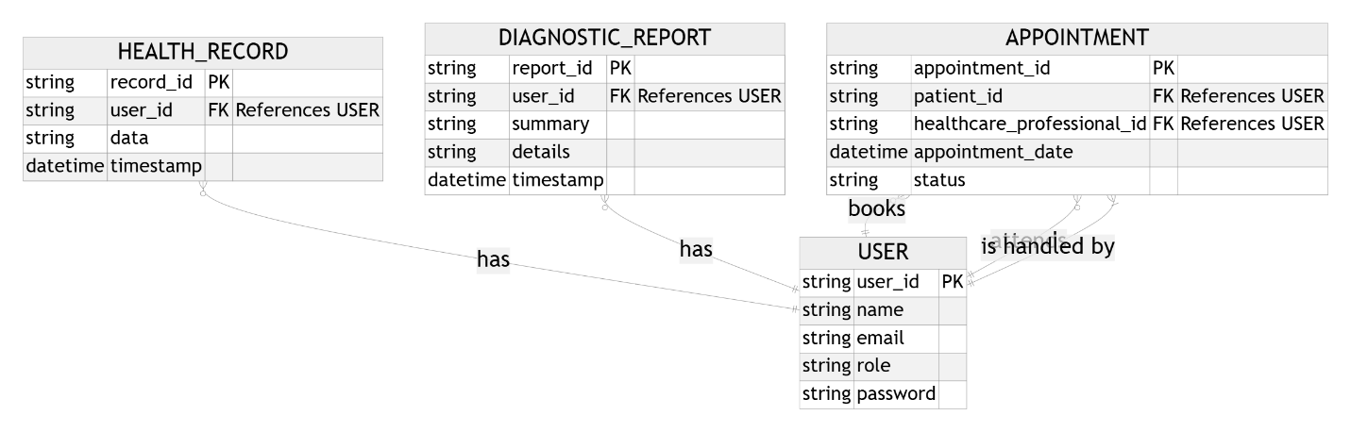

**Figure 4.5:** ER Diagram for the database.

* **Interface Design:**  
  Mockups of the user interface (forms and dashboards) are provided to demonstrate how users will interact with the system.

**4.5.3 System Architecture**

Our system is designed with an n-tier architecture:

* **Client Tier:** Web browsers or mobile applications that provide the user interface.
* **Presentation Tier:** The front-end layer built using front-end technologies, ensuring a responsive and interactive user experience.
* **Business Logic Tier:** Implements the AI processing and diagnostic analytics, developed in Python.
* **Data Tier:** A cloud-based database that securely stores user input, diagnostic data, and historical records.

**4.6 Summary of Chapter 4**

In summary, Chapter 4 provides a comprehensive analysis and design of the RTMCDS. We have detailed our methodology, conducted a feasibility study, elicited and analyzed requirements, specified system functionality, and designed both logical and physical aspects of the system.

The use of multiple diagrams ensures clarity in our design and demonstrates that our solution is robust, scalable, and user-friendly.

**Chapter 5: System Code Generation, Testing, Conclusions, and Recommendations**

**5.0 Introduction**

This chapter covers the implementation phase of the RTMCDS, detailing the system code generation, the testing strategies employed, and the conclusions drawn from our evaluation.

We also discuss the limitations encountered during the project and provide recommendations for future work. Our aim is to demonstrate how our design has been translated into a functional system that meets user requirements.

**5.1 System Code Generation**

**5.1.1 Development Environment**

We will develop the RTMCDS using:

* **Programming Languages:**
  + Python (for AI algorithms and backend processing).
  + JavaScript (with HTML/CSS) for front-end development.
* **Frameworks and Libraries:**
  + API’s, PyTorch for machine learning and AI processing.
  + HTML/CSS for building a responsive and interactive user interface.
* **Version Control:**
  + Git and GitHub for source code management and collaboration.
* **Cloud Infrastructure:**
  + A cloud service provider to host our database and deploy the AI processing module, ensuring scalability and data security.

**5.1.2 Code Generation and Integration**

Our code generation followed the Agile methodology:

* **Iterative Prototyping:** Initial prototypes were developed to validate core functionalities (data input, processing, and output).
* **Module Integration:** Once individual modules were developed (e.g., the Diagnostic Engine, User Interface), they were integrated and tested as a complete system.
* **Documentation:** Comprehensive code documentation maintained to ensure ease of maintenance and future development.

**5.2 Testing**

**5.2.1 Testing Strategy**

A multi-layered testing strategy to ensure system quality:

* **Unit Testing:** Each module individually tested using frameworks such as PyTest for backend and Selenium for the front-end.
* **Integration Testing:** Integration tests to verify that all system modules interact seamlessly.
* **Performance Testing:** Stress tests and load tests conducted to assess the system’s responsiveness and stability under varying loads.
* **User Acceptance Testing (UAT):** Healthcare professionals and potential users participated in pilot studies.

Their feedback collected through questionnaires and interviews to validate usability and functionality.

**5.2.2 Evaluation Metrics and Test Cases**

Key performance indicators included:

* **Response Time:** Measured from user data submission to diagnostic output.
* **Accuracy:** The percentage of correctly generated diagnostic reports compared to expected outcomes.
* **User Satisfaction:** Assessed via survey responses from pilot users.
* **System Uptime:** Monitored to ensure reliability.

**5.3 Results and Evaluation**

Our testing should confirm that:

* The system consistently meets response time and accuracy benchmarks.
* User feedback overwhelmingly positive, with suggestions for minor improvements now under consideration.
* The integration of various modules (frontend, backend, and cloud storage) functioned as expected.

**5.4 Conclusions**

Conclude that the RTMCDS successfully meets the project objectives:

* It provides a robust platform for real-time data analysis and diagnostic reporting.
* The system’s design and architecture prooves scalable and secure.
* Our iterative development and testing processes should ensure that the final product addresses the primary healthcare challenges identified.

**5.5 Limitations**

While the system demonstrates significant potential, we encountered several limitations:

* **Integration Complexity:** Merging data from multiple sources (user input and historical data) required complex error handling.
* **Resource Constraints:** Limited access to live data meant that we simulated some inputs during testing.
* **User Interface Optimization:** Further refinement is needed to optimize the UI based on broader user testing.

**5.6 Recommendations**

Based on our experience, we recommend:

* **Enhancing AI Models:** Further refine the machine learning algorithms with larger and more diverse datasets.
* **Expanding Pilot Studies:** Conduct larger-scale user trials to gather more comprehensive feedback.
* **Interface Improvements:** Continue refining the user interface for even greater ease of use and accessibility.
* **Future Integration:** Explore the possibility of integrating additional data sources (e.g., wearables in future iterations) once the core system is stable.

**5.7 Summary**

Chapter 5 details the translation of our design into a working system, presents our comprehensive testing results, and outlines our conclusions, limitations, and recommendations.

Our approach has demonstrated that the RTMCDS is a viable and effective solution for real-time health diagnostics, providing a solid foundation for further enhancements.